TECHNICAL DESIGN SPECIFICATION

Registration Application

Created By: Bac Bui, Erik Bollinger, Jennifer Burmester

Table of Contents

- Application Overview Page 3
- System Processes Page 4
- System Flow Page 5
- Object Model Page 6
- User Interface Page 7
- Data Structure Page 10
- Test Case Page 11

1. Application Overview

The Registration Application is an application tool that allows students to Add a Class, Drop a class, View available courses, in addition to course capacity, and View Registered Courses. A student will not be allowed to join a course that is already full. This application also provides security for users by allowing new users to create a new account, and an authenticated user to provide a username to login. A confirmation message will be displayed once a student Adds or Drops a class. This application data will be stored in a text file format and will be build using JAVA.

2. System Processes

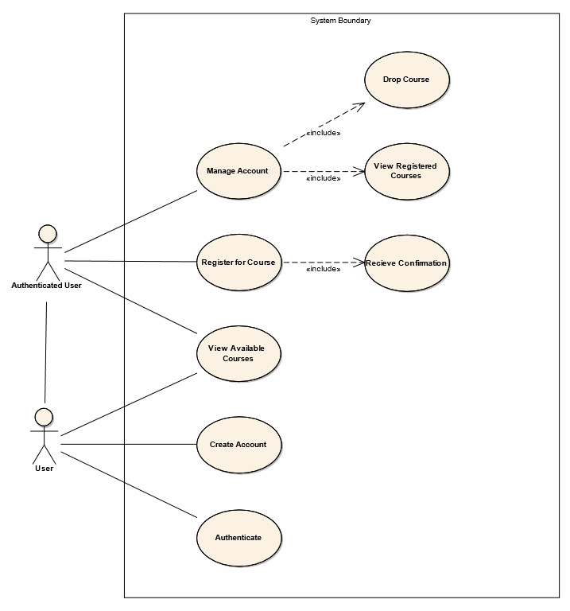
3. System Flow

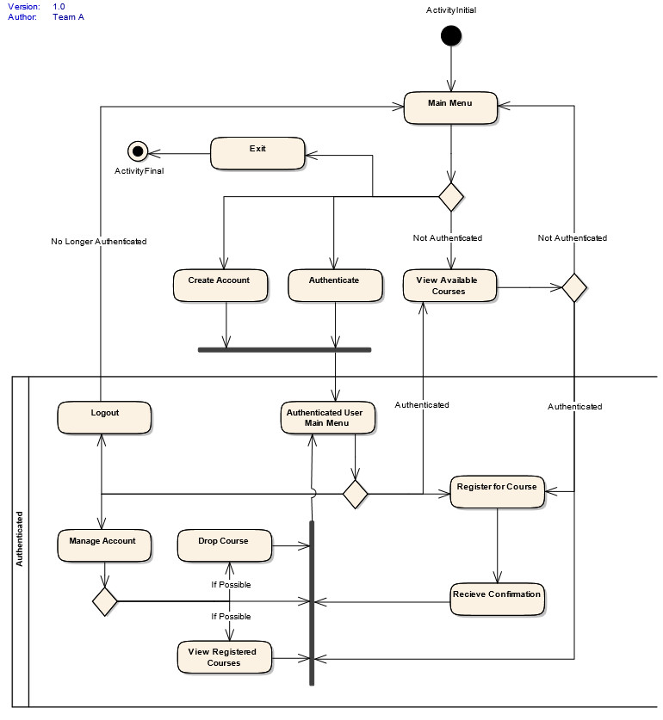
4. Object Model

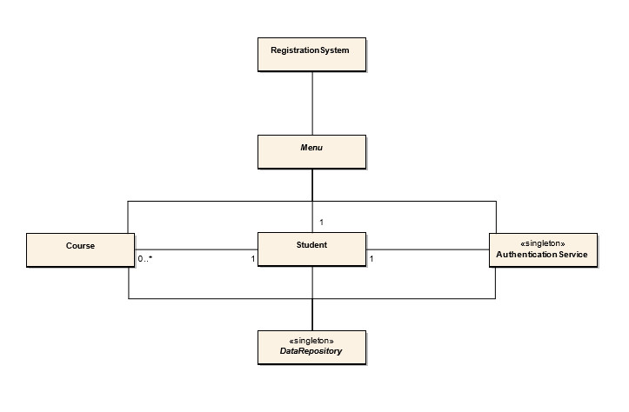
5. User Interface

5.1 Guest User
Application launches with guest access. The options below will be provided:

C = Create Account
L = Login
V = View Available Courses
X = Exit
Enter option - Press Enter_________

5.1.1 Create Account/Login
User enters username then presses Enter to create new account/login, then menu of step 5.2 will be rendered. If user enters nothing to any question and presses Enter, transaction will be canceled, and the menu of step 5.1 will be rendered.
User Name: ______________________
Enter all question then press Enter to create account
Enter nothing to cancel and go to the previous menu

5.1.2 View Available Courses
A list of all available courses that are not full will be displayed, and then menu of step 5.1 will be rendered.

5.1.3 Exit
Application will be terminated.

5.2 Authenticated User
If user is an Authenticated user then the below options will be displayed:

A = Add Class
B = Drop Class
R = View Registered Courses
V = View Available Courses
L = Log out
Enter option - Press Enter ____

5.2.1 Add Class
Add class option will be canceled if user enters nothing then presses enter.
Once user enters class identification number and presses Enter.
Application will validate for class identification number, to validate if student already enroll for this class, and availability of class.
If class is allowed to add, then confirmation message will be displayed, Menu of step 5.2 will be displayed.
Otherwise error message will be displayed. This menu will be re-displayed.

Please enter class identification number: _________
Enter nothing - press Enter to Cancel

5.2.2 Drop Class
Drop class will be canceled if user enters nothing. Menu of step 5.2 will be displayed.
Once user enters class identification number and press Enter, then application will validate if student already enroll for this class. If student did not enroll for this class an error message will be displayed, and menu of this step will be re-displayed.
If class is allowed to drop then confirmation message will be displayed. Menu of step 5.2 will be displayed.

Please enter class identification number: _________
Enter nothing - press Enter to return to Main Menu

5.2.3 View Registered Courses
A list of user’s registered courses that are not full will be displayed. User may choose to return to menu 5.2. User may also enter a CourseID to drop a class.

5.2.4 View Available Courses
A list of all available courses will be displayed. User may choose to return to menu 5.2. User may also enter a CourseID to add a class.

5.2.5 Logout
System will revert to guest mode and step 5.1 will be rendered.

6. Data Structure

6.1 Course
CourseID String(5)
CourseName String(30)
CourseDescription String(300)
Instructor String(50)
AvailableSeats Integer
MaximumSeats Integer
CourseDates String(50)

6.2 Student
Username String(5 to 10)
CourseID List<String>

7. Test Cases

7.1 Authenticate to Register
Users who are not authenticated can not register for courses.

7.2 Confirmation
Users who register for a course will receive confirmation.

7.3 Privacy
Users can not view other user's data.

7.4 Full Courses
Users can not register for a class that is at capacity.

7.5 Registered to Drop
Users must be registered for a course to drop the course.

7.5 Course Capacity
When users add and drop courses the course capacity must reflect the change.

